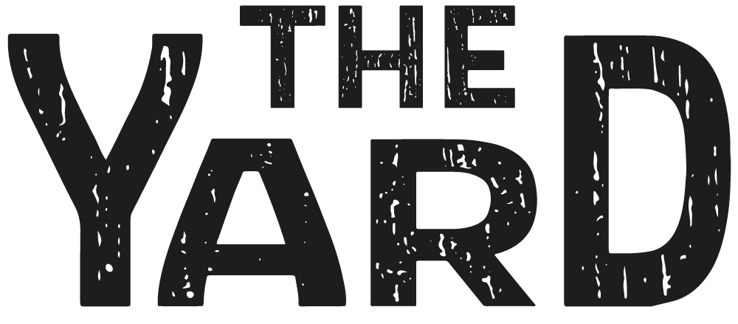
Market

Guest traders of The Yard Market are very kindly requested to adhere to these terms and conditions. This will save us from having a not very nice discussion about your attendance at future events, should any of the rules be broken. Please also ensure you have read all of the info on our website relating to payments and deposits.

Operating Hours:
- The Yard Market Dundee’s operating hours vary by venue and day. Timings are available via Events on Facebook. You need to be set up and ready to serve customers from opening time
- Traders are obliged to remain open for the agreed hours of operation
- If trading units are sold out of products, Traders must inform the duty Yard Market Manager to agree next steps
- Traders should not leave The Yard Market any earlier than the closing time unless agreed with the duty Yard Market Manager
- Traders are obliged to stop trading at the predetermined time and must not run over
- If for any unforeseen, emergency circumstances, a Trader must close the trading unit they must notify the duty Yard Market Manager

Support for promotion of the Market in advance of the event:
- It’s part of your attendance at the market to take part in actively promoting your presence
- Please ensure you are sharing, liking and commenting on The Yard Market pages and event page and all posts across social media
- Please like our Facebook page and follow us on Instagram
- Please also post about your presence at the event
- Tell all your friends and contacts and invite them to the event on Facebook
- The further the word spreads, the more customers we are likely to attract which is good for us all and absolutely vital to all of our future success
- We may use images of you or your products in future advertising, by signing up to attend you are giving your consent for us to do this. Please notify us if you do not want us to do this
Staff Conduct:
- Traders are required to behave in a manner in keeping with The Yard Market’s friendly culture
- The Yard Market will not tolerate abusive, aggressive or threatening behavior to the general public, other traders, The Yard Market staff and their representatives
- Traders must not smoke with in view of their trading unit

Risk Assessment

The Yard Market has carried out a Risk Assessment. The Yard will ensure that safety procedures are being adhered to by completing a Safety Check and an individual Trader Check at each event for both fire and general health and safety. A Food Safety Check will also be carried out to ensure compliance with all food safety regulations.

Traders are required to have in place the following and a copy of the appropriate documentation (where relevant to your business) should be submitted with the Booking Form:

- Risk Assessment
- Public Liability Insurance of a minimum of £5m for Traders and £1m for crafters
- Proof of Local Authority Registration / Food Hygiene Info Scheme Status (PASS)
- Valid Street Traders Certificate of Compliance if applicable (Scotland only)
- HACCP documentation
- Food Hygiene Training Certificates
- Allergen Matrix
- Event Menu
- Food Unit Internal layout plan ( only if they do not have a certificate of compliance)
- Photos of the unit ( only if they do not have a certificate of compliance)
- Health & Safety Policy/Risk Assessments/ COSHH documentation
- Electrical Installation documentation
- PAT test documentation if applicable
- Gas Safety Certificate if applicable
- Any other product certification such as UKCA for toys
- A valid CPSR is required for all cosmetic or toiletry products to be sold

Selection of Traders, Trading Unit and Surrounding Area:
- Preference is given to those makers who are not already exhibiting with another provider in the locality
- The Yard Market curates the makers for each event offering a variety of items for customers. Please only bring to the events what is noted on your application form. We may ask you to remove unlisted items
- Please note this market is for businesses looking to showcase their own work. All items sold MUST be made by you. No exceptions apply!
- Traders may only sell products as agreed in advance with The Yard Market and if required, passed by Environmental Health
- Traders who wish to bring additional products to The Yard Market which haven’t previously been agreed must make a formal request by e-mail to The Yard Market to stine.hope@hotmail.co.uk
- Traders must keep all products / equipment within their trading unit unless they receive the express permission of The Yard Market
- Traders must keep their trading unit and surrounding area clean and tidy. All boxes must be stored underneath or neatly behind the trading unit leaving a clear area for pedestrians or customers with wheelchairs to pass safely
- All Traders are responsible for cleaning up spillages
- The Trader’s trading name must be displayed on the trading unit
- People working on the trading unit must have a good knowledge of their products for sale

Legal and Safety Requirements
- Food and drink in packages must have full ingredients listed on the product with the allergens highlighted as instructed by the Food Safety Act
- For food and drink packaged at point of purchase, a list of all ingredients must be available for all products upon request
- Candles and wax melts must all have compliant product safety labels
- All toys must adhere to the compliant product safety regulations
- Any product advertised as for adults, children and/or animals, must meet all government and council health & safety standards.
- Vendors must adhere to copyright laws and not sell goods using another company's image
- All electrical installations must display valid PAT tested labels.

Health and Safety:
- All Traders are required to comply with all necessary Health and Safety, legislation and regulations
- Everyone on site has a responsibility for the Health and Safety of themselves and those around them
- Suitable footwear should be worn throughout build, operational and take down periods
- Traders are obliged to provide Fire Fighting equipment as necessary for their unit, in line with the risks and controls agreed to in their Trader Fire Risk Assessment
- The Yard reserves the right to inspect units at any time without prior warning in order to ensure Health and Safety standards are being kept to their highest level
- Traders must adhere to all requests from The Yard Management or Health and Safety officers in a timely manner
- Traders must return all documentation and information on the date specified
- All skincare products must have undergone all required cosmetic safety assessments (CPSR) and must be registered with the UK Government Cosmetics Notification Service.
- All candle products must have undergone all required safety assessments and you should have appropriate certifications as required
- All toys must be UKCA compliant
- AI generated images are prohibited to be sold as art

Food Safety (only for food traders)
- All Traders are required to comply with all necessary Food Safety and Hygiene, legislation and regulations
- Food Hygiene Information Scheme in Scotland results must be kept on site for inspection at any time
- Documentation relating to the above scheme should be displayed within the trading unit. Please ensure documentation is available at all times and that the Scottish scheme has been used
- Traders must declare or display all allergen information at all times within their trading unit
- Food Traders must complete and return The Yard Food Traders Form and any other necessary documents on the date specified on our website
- All Traders selling food and drink must be registered with their Local Authority
- The Yard reserves the right to inspect units at any time without prior warning in order to ensure Food Safety standards are being kept to their highest level
- All Traders selling food / drink must have an appropriate HACCP-based food safety management system in place
- All Traders must have Public and Product Liability Insurance
- All relevant Traders must adhere to rules regarding trading standards

Utilities / Equipment: (only for food traders)

Gas:
- All Traders using LPG must ensure that cylinders have been checked by a GAS SAFE registered fitter and must come with a valid Gas Safe Certificate
- All LPG used for cooking must be stored outside the trading unit at least 1 meter away from cooking appliances
- The LPG bottle MUST NOT exceed 19 kilo
- Spare cylinders are not permitted within the site
- All Traders using LPG must provide a dry powder fire extinguisher and fire blanket
- Fire fighting equipment must be tested on an annual basis
- BBQs should be positioned at least 1 meter from any stall and cooking ranges within stalls should be positioned at least 600mm from any material
Electricity
- Please bring an extension lead with you so that you can connect to our power supply
- All electrical equipment must come with a valid PAT Test Certificate. Traders must have proof of purchase if the piece of equipment is less than 1 year old, and therefore doesn’t have a PAT Test certificate. No electrical equipment without a valid PAT test certificate will be allowed on site. Current stickers must be visible

Water
- All waste water must be disposed of in the central waste disposal area, at the back of house. Water must be transported in a sealable container. You will be shown where this is
- Failure to transport waste water in a sealed container will result in a fine to the Trader
- Access to a water tap is provided. You will be shown where this is
- All catering units should have 2 sinks. One for cleaning and one for handwash, depending on the nature of your trade

Accidents/First Aid
- In the event of an accident which requires assistance, Traders should alert The Yard Duty Manager
- All near misses must be reported to The Yard Market Duty Manager
- For First Aid for minor accidents, please contact The Yard Market Duty Manager. If further assistance is required, The Yard Market Duty Manager will call for an ambulance

Waste Disposal:
- All cardboard must be flattened and bundled up with string, not loosely disposed of and taken away with you
- All rubbish must be bagged and taken away with you
- All waste and combustibles must be stored correctly away from sources of ignition
- Traders that generate fat and oil waste are responsible for removing this from the site
- Waste must be separated into food waste, metal, plastic, glass, paper and cardboard for collection
- Waste water must be transported in a sealed container to the central waste disposal area, back of house

Other Information:
- Storage is not available onsite at The Yard Market
- Traders’ goods and possessions remain their responsibility. Please make sure your possessions are kept safe at all times. Any loss or damages to Traders property is their sole responsibility
- Traders must be aware that there may be other products within The Yard Market which are similar to theirs
- Traders must adhere to all weights and measures stipulations as required by law
- Traders must not touch or tamper with The Yard Market’s technical provisions, this including speakers and lights. Please notify The Yard Market Management if you have an issue with either
- Liability for takings on the day is that of the Trader, The Yard accepts no responsibility for this
- Traders should not play their own music as live music is being provided by The Yard Market
- Traders must adhere to all the rules contained within this Operating Rules and Health and Safety Rules and Procedures document
- Traders must return all documentation and information on the date specified

Insurance
- Stallholders shall free and relieve Yard Market Events and keep it and its officials, servants and agents indemnified against all claims for personal injury whether fatal or otherwise, loss or damage to property or any other losses, damage or expenses, however caused or incurred, which may arise through the occupation and use by the Stallholder of the Subjects. Stallholders shall take out and keep in force public liability insurance for a minimum of ONE MILLION POUNDS (£1,000,000) STERLING with a reputable insurance company to be approved by Yard Market Events and shall supply a copy of the policy and most recent premium receipt to Yard market Events at the time of bookings.
Cancellation Policy - The Yard Market
- The Yard Market reserves the right to cancel the event or any part of the event at any time without liability to The Yard Market, the organisation or its directors if it believes the health and safety of Traders or the public is at risk.
- If we need to cancel, your payments will be non refundable
- Traders are advised to carry insurance for loss of earnings due to late cancellation.
- The Yard Market does not accept responsibility for Traders’ loss of earnings
- The Yard Market shall be under no liability in any way for any expenditure, liability, damage or loss sustained or incurred by stallholders because of delay or failure to perform any of its obligations if the delay or failure results from circumstances beyond its reasonable control.
- The Yard Market’s Terms and Conditions may be amended and re-issued from following any legislative changes or changes in the systems of work at The Yard Market. Revised documents will be issued to all Traders.
- The Yard Market reserves the right to refuse or deny continued participation of any Trader not in complete compliance with The Yard Market Terms and Conditions or any Trader carrying out any action that is deemed unacceptable to The Yard Market.

  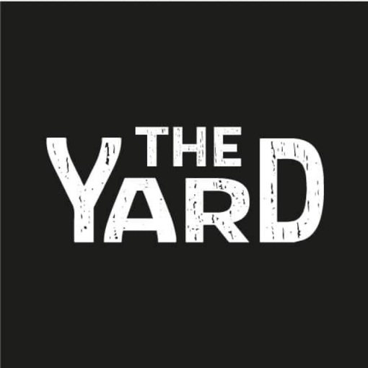
  Stine Hope
  P. 07841 887 825
  E. stine.hope@hotmail.co.uk

Date of issue: Jan 2025

